Site Map

Overview
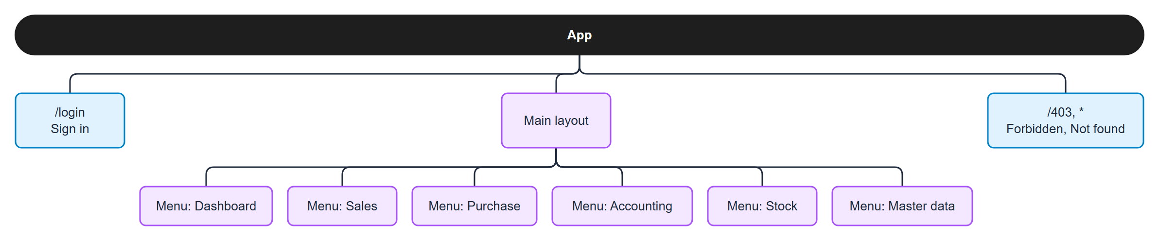
Figure 1. Overview

Pages of each menu
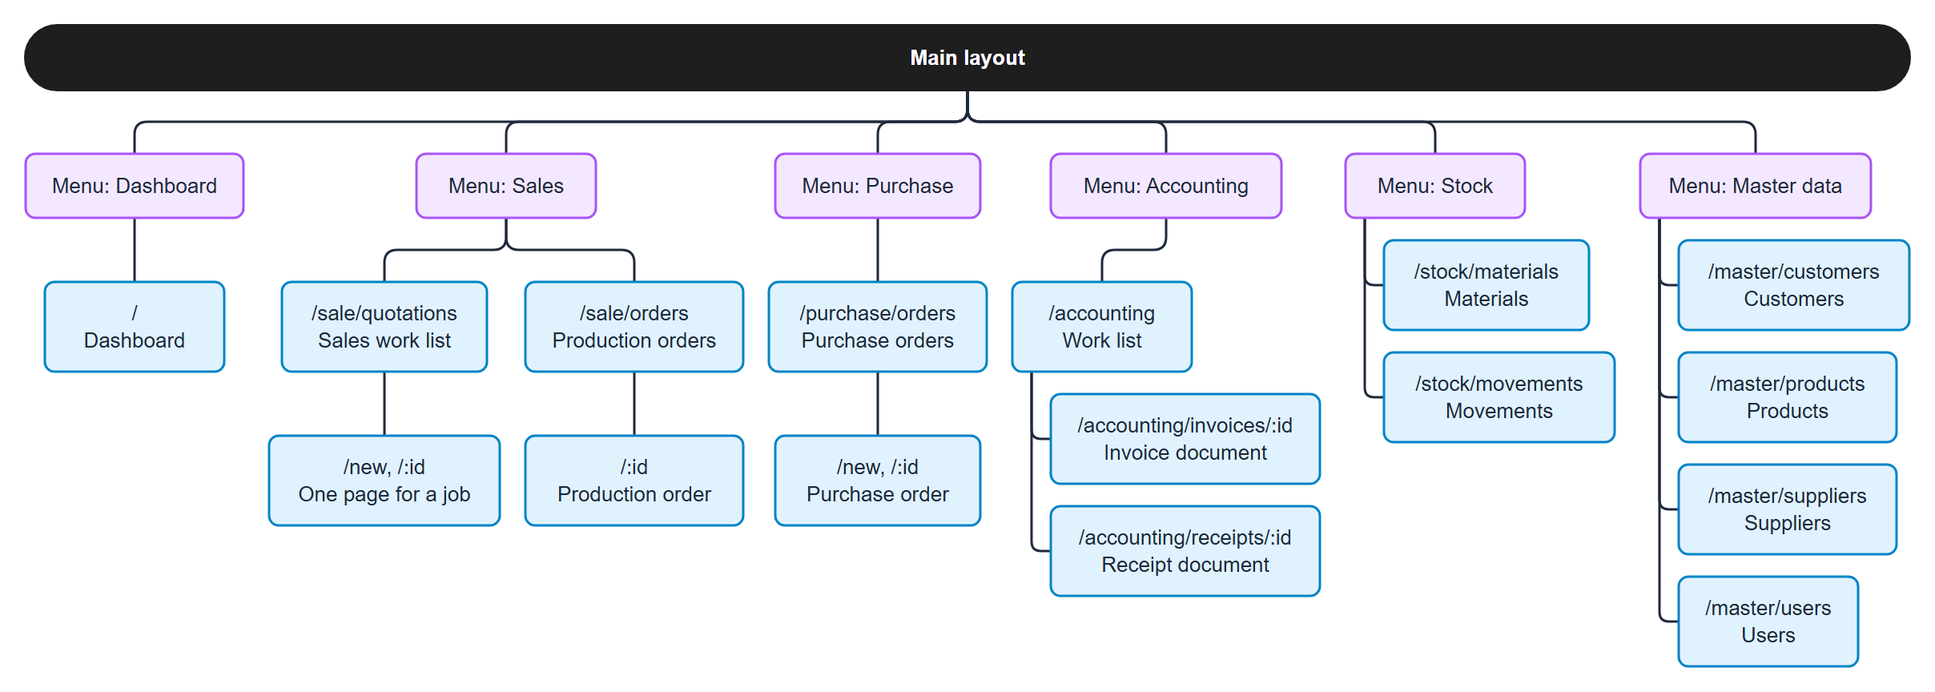
Figure 2. Pages of each menu

Page table
Menu | Page | Path | Admin | Sale Worker | Factory Worker
Dashboard | Dashboard | / | all tiles + chart | orders | orders
Sales | Sales work list and one page for a job | /sale/quotations | yes | yes | no
Sales | Production orders | /sale/orders | yes | view only | view + processes + start + progress
Purchase | Purchase orders | /purchase/orders | yes | no | yes
Accounting | Work list | /accounting | yes | no | no
Accounting | Invoice and receipt documents | /accounting/invoices/:id, /accounting/receipts/:id | yes | no | no
Stock | Materials | /stock/materials | yes | view | change
Stock | Movements | /stock/movements | yes | view | view
Master data | Customers | /master/customers | yes | view | no
Master data | Products | /master/products | yes | view | view
Master data | Suppliers | /master/suppliers | yes | no | view
Master data | Users | /master/users | yes | no | no
– | Sign in, Forbidden, Not found | /login, /403, * | any | any | any

What is on each page
Page | Content
Sign in | email and password
Dashboard | order tiles (Draft, In progress, Completed); for the Admin also the invoice tiles and a chart of orders by status
Sales work list | one row per job with its step (Draft, Confirmed, In production, Done)
QT page (one page for a job) | the steps of the job, customer, lines and total, Print button, customer PO upload (number, date, file), Confirm button; after Confirm a link to the production order (the factory adds the processes there)
Production orders | list of orders with their status
Production order | processes (Factory, Admin: before the start; Sale: read only), start, progress, the customer PO file, QT link, evidence upload (images and documents)
Purchase orders | the materials that are Low or Out (each with Create PO), the PO form, the PO list (see below)
Accounting | two sides: customers pay us (tabs To invoice / Waiting for payment / Paid; Issue invoice and Record payment in small dialogs; Open receipt) and we pay suppliers (tabs To pay / Paid out: the received purchase orders; the payment is recorded on the PO page)
Invoice, receipt | the document, ready to print
Materials | materials with lots, total and stock status; Add / Deduct / Adjust a lot
Movements | the history of every stock change
Customers, Products | list, search, add / edit / delete (products with their BOM)
Suppliers | suppliers with their items and prices
Users | list, add / edit / delete; a Worker must choose the department Sales or Factory
Forbidden, Not found | message and a way back

Menus: each entry shows only for the roles and departments that may use it; a menu with one visible entry is shown as that entry alone. The first entry of a Factory Worker is labelled "Today"; it opens the Dashboard. The language (English / Japanese) can be switched on every page.

The Purchase page (one page)
Area | Content
Stock to buy | the materials that are Low or Out: remaining, minimum level, status, "Create PO"
PO form | supplier, required date, department, item lines, quantity, price, total
PO list | PO No., supplier, required date, status buttons
PO detail | lines, Print PDF, payment, attachments

Redirects
- /stock opens /stock/materials; /stock/:id is redirected to the material page.
- /sale/orders/new opens /sale/quotations: an order is made by Confirm QT, never by hand.
- /accounting/invoices, /accounting/invoices/new and /accounting/receipts open /accounting; the invoice and the receipt keep /:id as documents.
- Old addresses of pages that moved (/qt, /orders, /invoices, ...) are redirected to their new place.

